**AU‌ ‌2021‌ ‌-‌ ‌NoSQL‌ ‌Basics‌ ‌&‌ ‌Fundamentals‌ ‌**

 ‌

**Assignment: ‌ ‌**

 ‌

1. Import‌ ‌`travel-sample`‌ ‌bucket‌ ‌

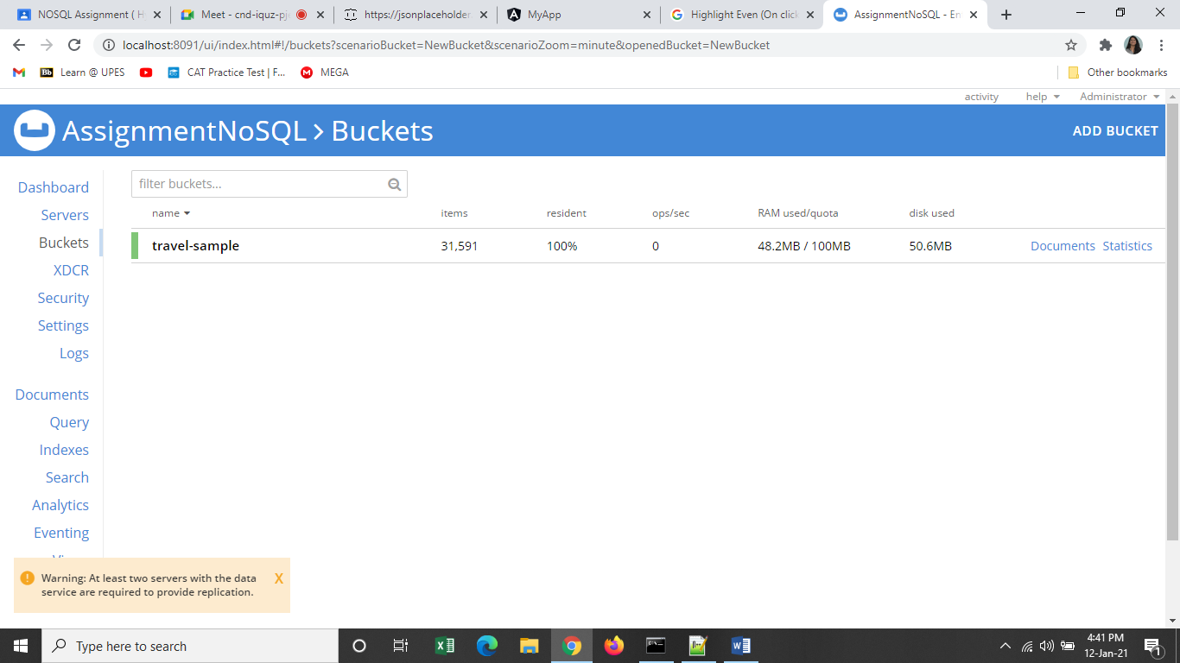

2. Write‌ ‌a‌ ‌query‌ ‌to‌ ‌get‌ ‌the‌ ‌sum‌ ‌of‌ ‌all‌ ‌distances‌ ‌where‌ ‌type=”route”‌ ‌for‌ ‌

each‌ ‌airline‌ ‌id.‌ ‌

select airlineid,sum(distance) from `travel-sample` where type="route" group by airlineid;

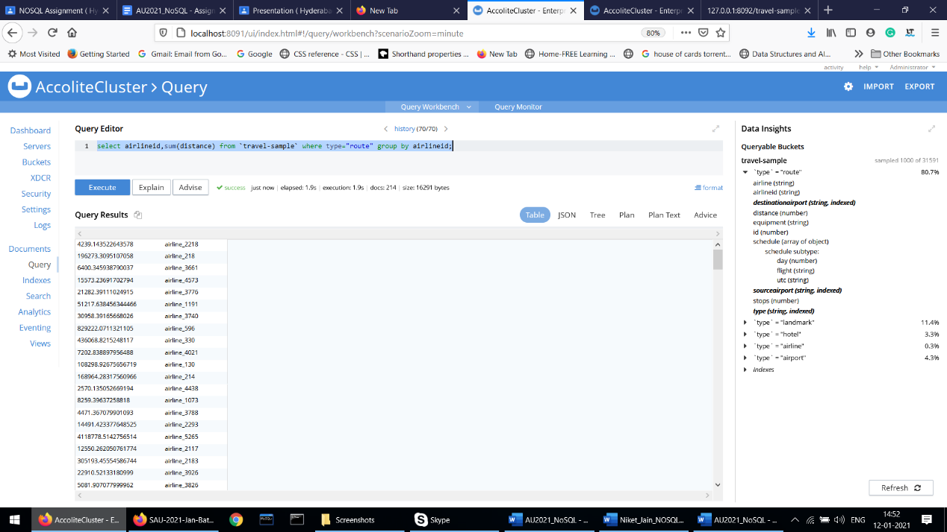

3.Write‌ ‌queries‌ ‌to‌ ‌join(LEFT,RIGHT,INNER)‌ ‌type=”route”&“airline”‌ ‌and‌ ‌

fetch‌ ‌the‌ ‌data‌ ‌whose‌ ‌sourceairport=”SFO”‌ ‌

a) Left Join

select t1.airlineid,t2.otherid from (select airlineid,sourceairport from `travel-sample` where type="route") as t1 left join (select meta().id,id as otherid from `travel-sample` where type="airline") as t2 on t1.airlineid=t2.id where t1.sourceairport="SOF";

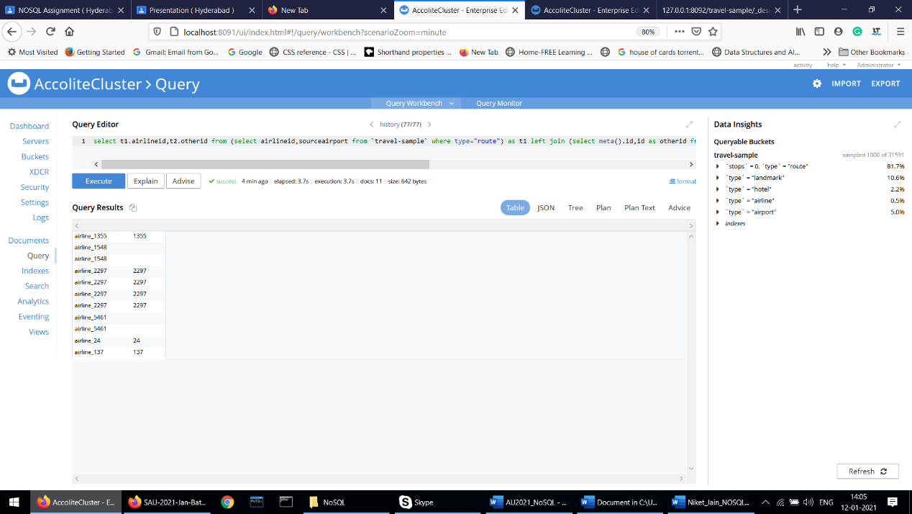

b) Right Join

select t1.airlineid,t2.otherid from (select airlineid,sourceairport from `travel-sample` where type="route") as t1 right join (select meta().id,id as otherid from `travel-sample` where type="airline") as t2 on t1.airlineid=t2.id where t1.sourceairport="SOF";

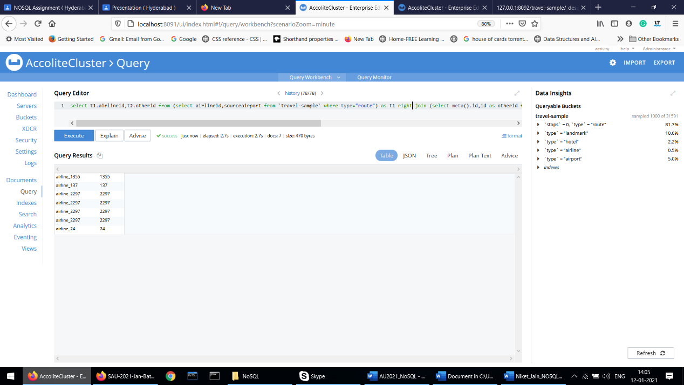

c) Inner Join

select t1.airlineid,t2.otherid from (select airlineid,sourceairport from `travel-sample` where type="route") as t1 inner join (select meta().id,id as otherid from `travel-sample` where type="airline") as t2 on t1.airlineid=t2.id where t1.sourceairport="SOF";

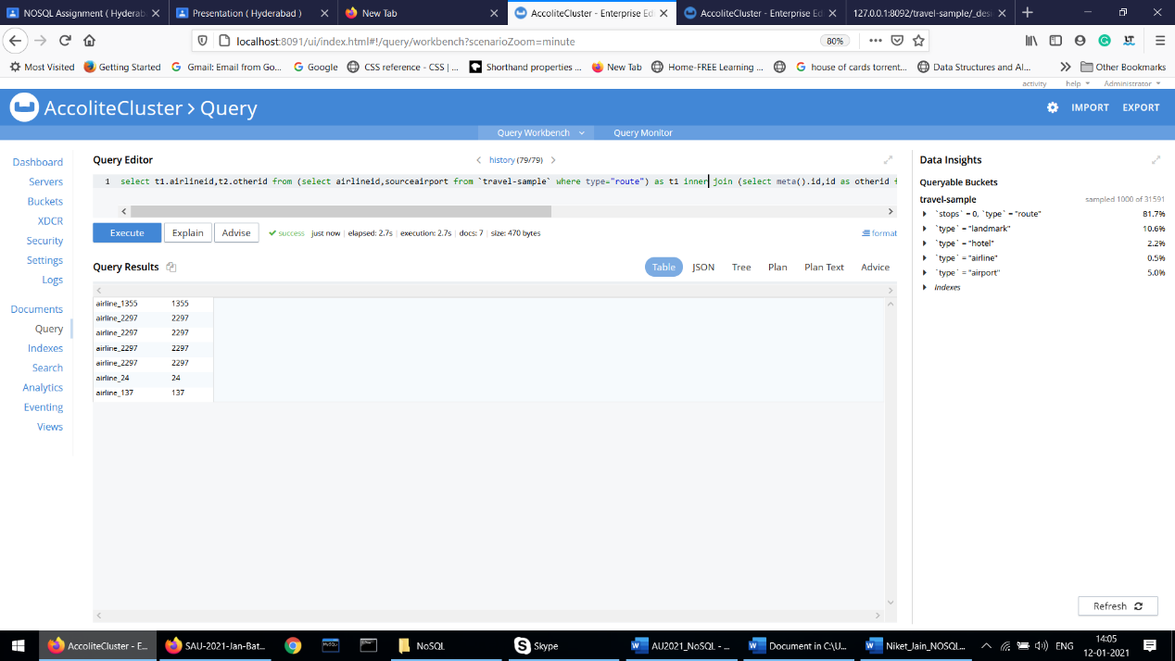

4. Write‌ ‌a‌ ‌mapreduce‌ ‌to‌ ‌get‌ ‌the‌ ‌number‌ ‌of‌ ‌all‌ ‌documents‌ ‌based‌ ‌on‌ ‌entities (type).‌ ‌

**Code in map**

function (doc,meta){

emit(doc.type,null);

}

// Tick group checkbox in results

**Code in reduce**

_count

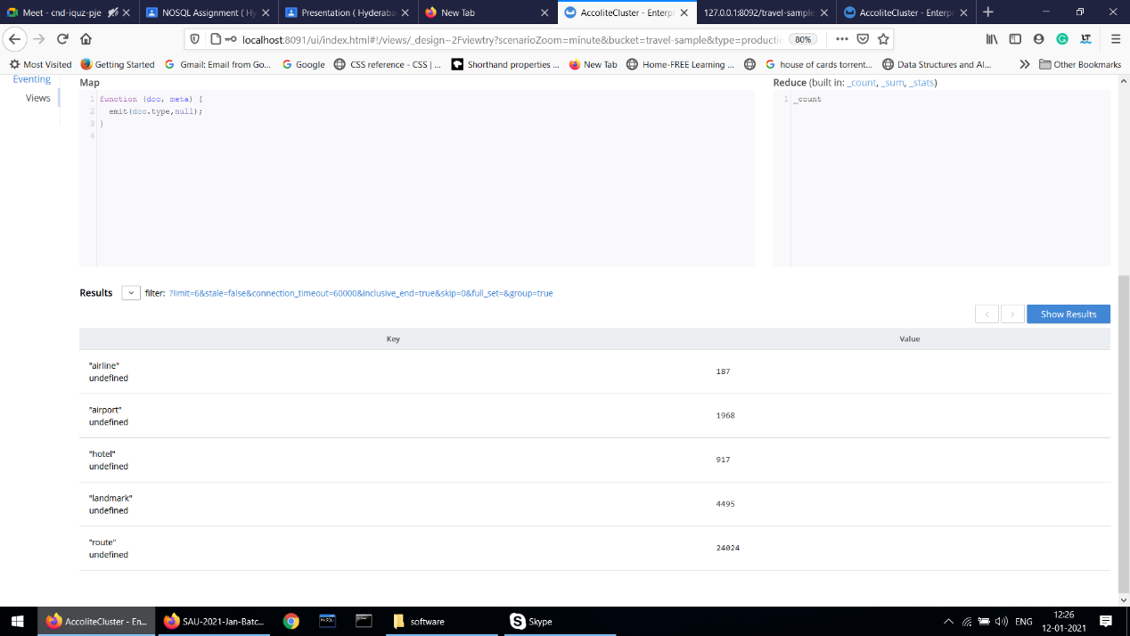

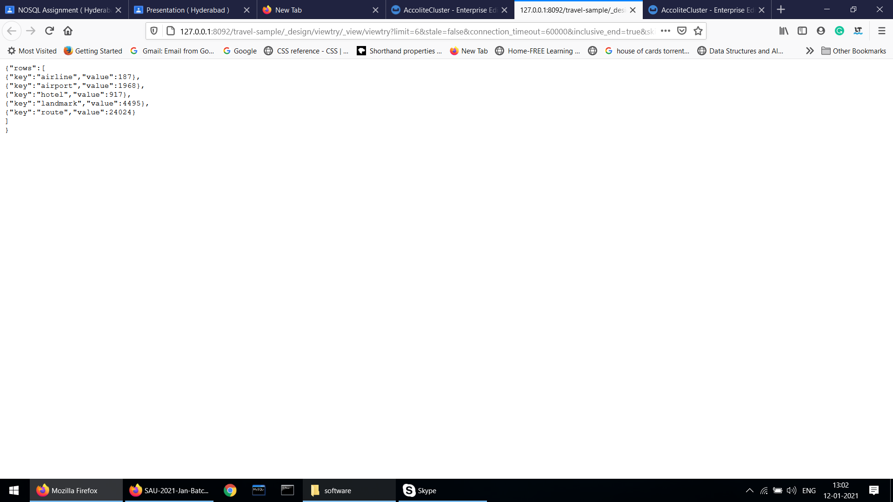

5. Refer‌ ‌CLI‌ ‌interface‌ ‌&‌ ‌try‌ ‌to‌ ‌export‌ ‌the‌ ‌travel‌ ‌sample‌ ‌data.‌ ‌Below‌ ‌are‌ ‌

the‌ ‌steps:

‌ ‌

a) Go‌ ‌to‌ ‌Couchbase‌ ‌Bin‌ ‌folder‌ ‌-‌ ‌C:\Program‌ ‌Files\Couchbase\Server\bin‌ ‌ ‌

b) Open‌ ‌Command‌ ‌Prompt‌ ‌from‌ ‌the‌ ‌bin‌ ‌folder‌ ‌

c) Run‌ ‌the‌ ‌below‌ ‌command‌ ‌to‌ ‌export‌ ‌the‌ ‌data‌ ‌from‌ ‌travel-sample‌ ‌bucket:‌ ‌

cbexport‌ ‌json‌ ‌-c‌ ‌couchbase://127.0.0.1‌ ‌-u‌ ‌<USER‌ ‌NAME>‌ ‌-p‌ ‌<password>‌ ‌

-b‌ ‌travel-sample‌ ‌-o‌ ‌C:/travelSample.json‌ ‌-f‌ ‌lines‌ ‌-t‌ ‌4‌ ‌

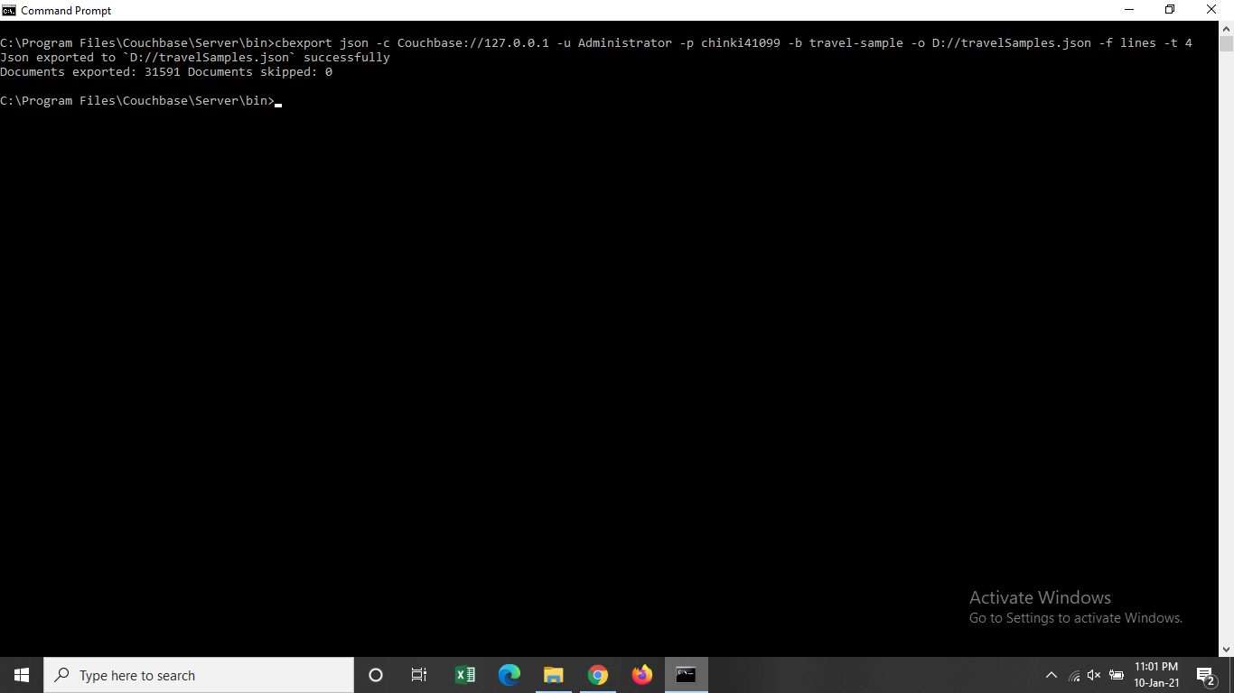

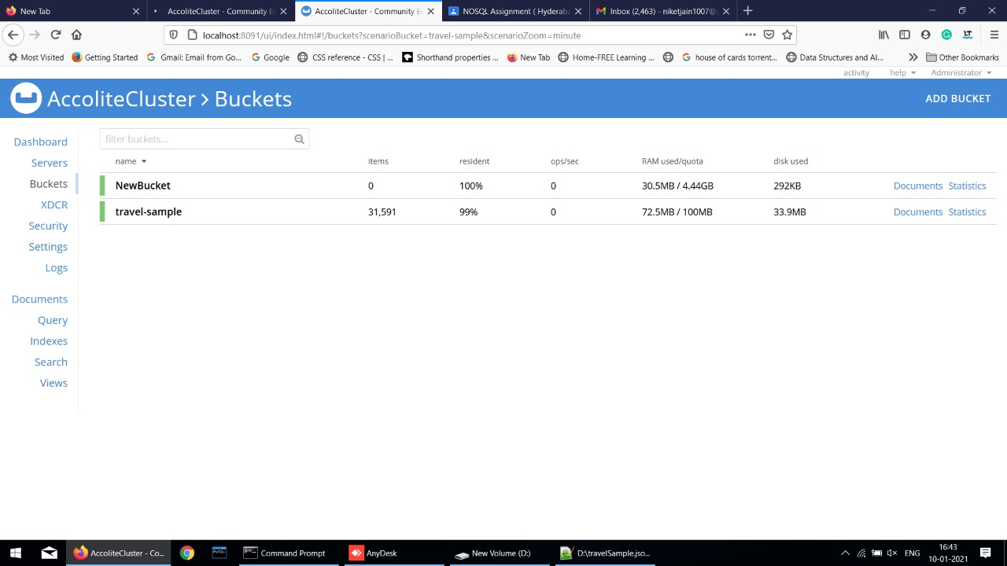

 ‌

D) Create‌ ‌a‌ ‌new‌ ‌Bucket‌ ‌“NewBucket”‌ ‌&‌ ‌import‌ ‌the‌ ‌data‌ ‌to‌ ‌it:‌ ‌

 ‌

cbimport‌ ‌json‌ ‌-c‌ ‌couchbase://127.0.0.1‌ ‌-u‌ ‌<User‌ ‌Name>‌ ‌-p‌ ‌<password>‌ ‌-b‌ ‌

NewBucket‌ ‌-f‌ ‌lines‌ ‌-d‌ ‌file://C:/travelSample.json‌ ‌-t‌ ‌4‌ ‌-g‌ ‌%id%‌ ‌

E) Once‌ ‌the‌ ‌data‌ ‌is‌ ‌imported,‌ ‌please‌ ‌attach‌ ‌the‌ ‌screenshot.‌ ‌

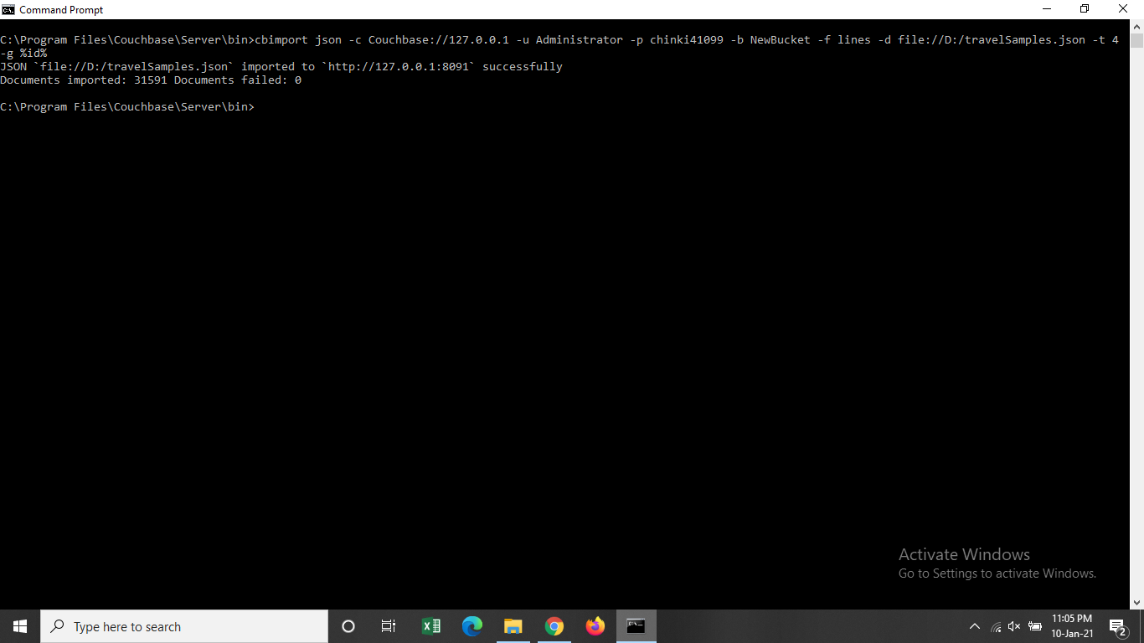

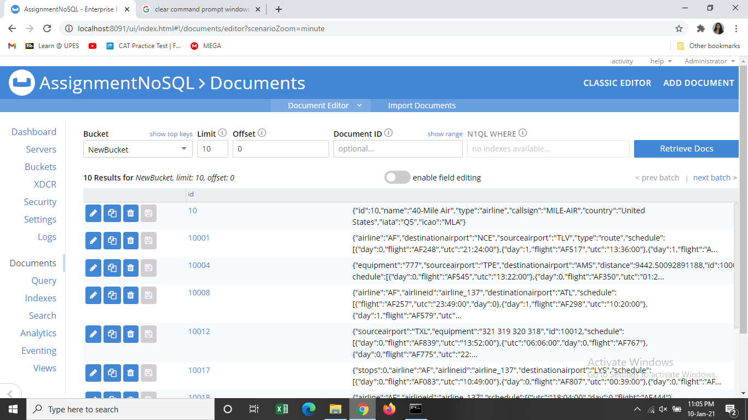

 ‌

Note‌:‌ ‌

-u‌ ‌-->‌ ‌UserId‌ ‌which‌ ‌you’ve‌ ‌created‌ ‌

-p‌ ‌-->‌ ‌password‌ ‌

-b‌ ‌-->‌ ‌bucket‌ ‌name‌ ‌